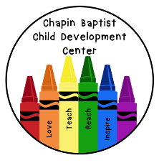
2’s Daily Schedule
7:00-8:00 Arrival, Child guided play, Centers
8:00-8:30 Transition, Clean up, Potty, Wash hands
8:30-9:00 Teacher guided lessons, Activity (Art, Bible, Science, Music, etc)
9:00-9:30 Snack, Clean up
9:30-10:00 Transition, Clean up, Potty, Wash hands
10:00-10:15 Songs, Finger plays, Morning activities
10:15-10:45 Outside (weather permitting) or Recreation Room, Gross motor play
10:45-11:00 Transition, Potty, Wash hands
11:00-11:30 Lunch, Clean up
11:30-11:45 Quiet activity (Books, Puzzles, etc.)
11:45-12:00 Transition, Clean up, Potty, Wash hands
12:00-2:00 Rest/Nap time
2:00-2:30 Transition, Potty, Wash hands
2:30-3:00 Snack, Clean Up
3:00-3:30 Child guided play, Centers
3:30-4:00 Transition, Potty, Wash hands
4:00-5:00 Outside (weather permitting) or Recreation Room, Gross Motor Play
5:00-5:30 Transition, Potty, Wash hands, Afternoon Cleaning
5:30-6:00 Child guided play, Afternoon cleaning, Final departures

